SEKOLAH RENDAH SRI MAWAR (YDAS002)
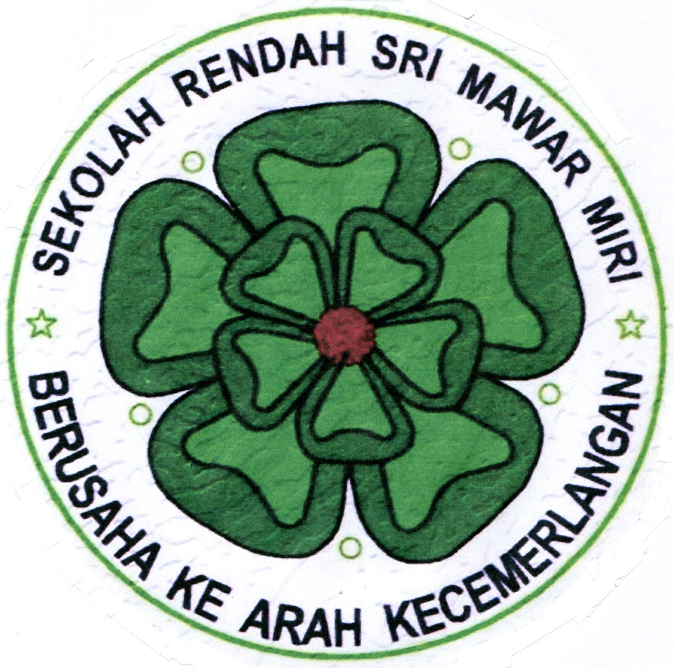
KK activities Schedule 2019
Date (Monday) | GROUP | Date (Wednesday)
7TH January (KK Registration) | GROUP B | 9th January (NO KK)
14th January |  | 16th January (NO KK)
21st January |  | 23rd January (KK Registration)
28th January |  | 30th January
2nd to 10th Feb (Chinese New Year Break)
11th Feb | GROUP B | 13th Feb
18th Feb | GROUP A | 20th Feb
25th Feb to 1st March 2019 (1st Mid Semester Exam)
4th March | GROUP A | 6th March
11th March |  | 13th March
18th March |  | 20th March
23rd to 31st March (1st Mid Semester Holidays)
1st April | GROUP B | 3rd April
8th April |  | 10th April
15th April |  | 17th April
22nd April |  | 24th April
29th April |  | 1st May (Labour Day)
6th May to 9th June (Bulan Ramadan & HARI RAYA)
25th May to 9th June 2019 (1st Semester Holiday)
10th June | GROUP A | 12th June
Sports Practice  17th June  24th June |  | Sports Practice  19th June  26th June
1st July (Occasional hols) | GROUP A | 3rd July
8th July |  | 10th July
15th July |  | 17th July
22nd July (Sarawak Day) |  | 24th July
29th July |  | 31st July
5th August to 9th August 2019 ( EXAM WEEK)
10th Aug to 18th August 2019 (2nd Mid Semester Holidays)
19th August | GROUP B | 21st August
26th August |  | 28th August
2nd Sept (Pub Hols) |  | 4th Sept
9th Sept (King’s Birthday) |  | 11th Sept
16th Sept (Malaysia Day) |  | 18th Sept
23rd Sept | GROUP A | 25th Sept
30th Sept | GP A competition | 2nd Oct
7th Oct | GP B Competition | 9th Oct
14th Oct (KK Closing) |  | 16th Oct (KK Closing)
23rd to 31st October( EXAM WEEK)
Total KK activities = 24 days (Mon) + 26 days (Wed)
Total Sports practice = 4 days

